**1. WRITE:**

|  |  |  |  |  |
| --- | --- | --- | --- | --- |
| channel | show | the news | ~~cartoons~~ | documentary |

I sometimes watch1 cartoons after school, before I do my homework. I love *Tom and Jerry!* But my favorite2 _______________ is a games show on Saturdays. When it’s finished my sister changes3 _______________ to watch her favorite show. It’s a4 _________ ______________ about life in space. Sometimes on Saturday evenings my family and I all watch a movie together. It is fun. Then my parents watch5 ______________. They watch it every evening.

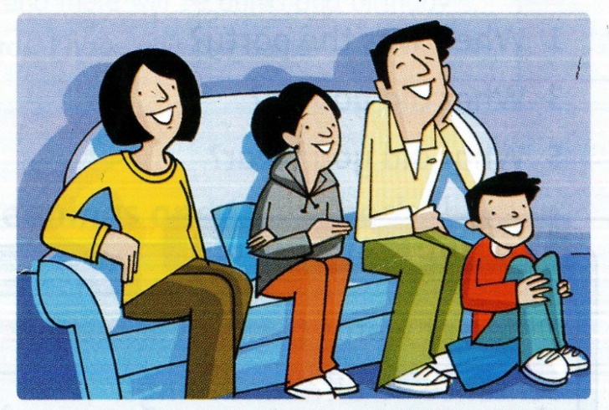

**2. READ and CIRCLE. THEN ASK and ANSWER:**

1) How **much / many** luggage do you take on vacation?

2) How **much / many** pens are there in your pencil case?

3) How **much / many** books do you have on your desk?

4) How **much / many** money do you have in your pocket?

**3. WRITE:**

|  |  |  |  |
| --- | --- | --- | --- |
| many | some | any | lots of |

Pete Do you have1 any tickets for the game next week?

Assistant Yes, of course. You’re quite early. We still have2 ____________ tickets left. How3 ____________ do you want?

Pete Four, please. Sue, doy have4 _____________ maney you can give me untit tomorrow? I want to buy all the tickets today.

Sue Sorry, Pete. I don’t have5 ____________ money today. But we have6 __________time. Let’s come back tomorrow.

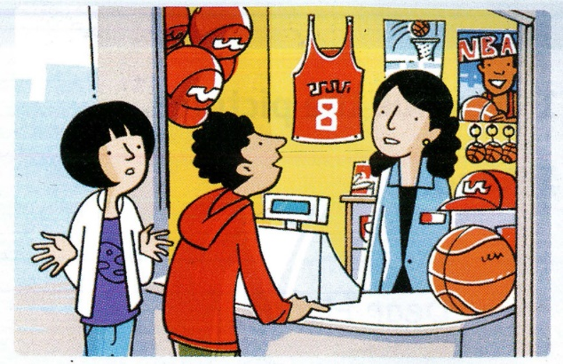

**4. WRITE:**

|  |  |  |  |  |  |
| --- | --- | --- | --- | --- | --- |
| idea | great | Why | ~~Let’s~~ | About | OK |

Mon 1 Let’s go to a restaurant for dinner tonight.

Boy That’s a good 2 __________________.

Girl 3 ________________ don’t we go to the pizza restaurant?

Mom We ate pizza yesterday. How 4 ______________ going to a Chinese restaurant?

Boy 5 ________________.

Girl That’s 6 ______________. Let’s go!

**5. COMPLETE THE WORD:**

|  |  |  |  |  |
| --- | --- | --- | --- | --- |
| ur | ir |  | er | or |

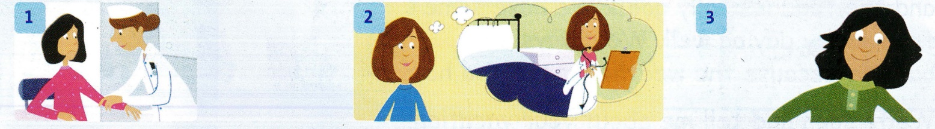

|  |  |  |
| --- | --- | --- |
| This girl h______t her arm. | When I grow up, I want to be a doct______. | I wore my new green sh____t. |

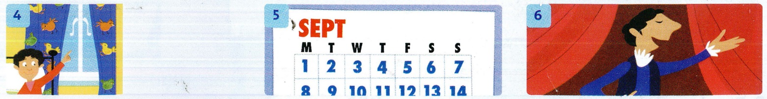

|  |  |  |
| --- | --- | --- |
| My c_____ tains are p____ple. | There are thirty days in Septemb______. | This person is an act____. |

**6. LOOK AND READ. WRITE YES OR NO. THERE ARE TWO EXAMPLES:**

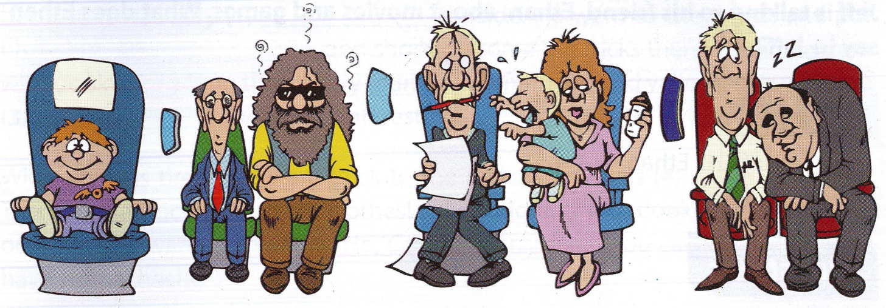

1. Only one of the men is sleeping. _________________

2. The man to the left of the woman has a red pen in his mouth. _________________

3. The man with long gray hair is wearing sunglasses. _________________

4. The boy wearing the purple T-shirt is crying loudly. _________________

5. The boy is eating a cheese sandwich. _________________

6. The man wearing a green tie has curly black hair. _________________

7. The woman looks very tired. _________________

**7. READ THE UNDERLINED WORDS. WRITE THEM IN THE CORRECT BOXES:**

1. Ly sent an email to planets far away.

2. In the cartoon, the mouse played a trick on the cat.

3. I was disappointed with the shows.

4. Last night, I was tired and slept on the sofa.

5. The baseball stadium was very crowded.

|  |  |  |  |  |
| --- | --- | --- | --- | --- |
| **Verbs**  sent |  | Adjectives |  | Nouns |

**8. LOOK AT THE PICTURES. WRITE WHAT DID AT THESE TIMES:**

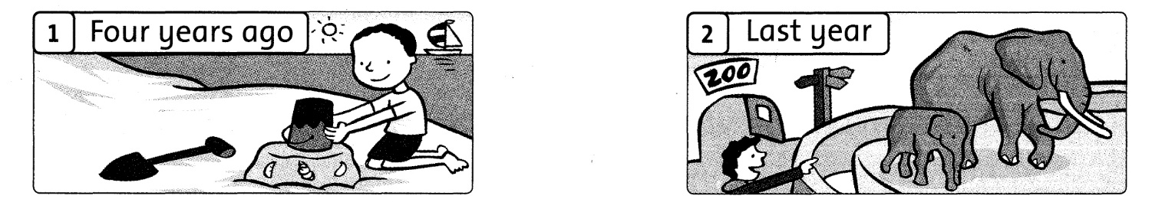

|  |  |
| --- | --- |
| Four years ago Bill was on the beach. |  |

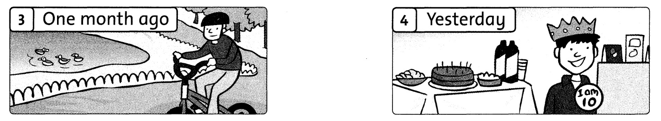

|  |  |
| --- | --- |
|  |  |

**9. CIRCLE THE ODD-ONE-OUT:**

|  |  |  |  |
| --- | --- | --- | --- |
| 1 | card candles party departure | 2 | passport robot luggage passenger |
| 3 | TV coin cell phone MP3 player | 4 | game poor soccer stadium |
| 5 | fresh first second third | 6 | cartoon documentary the news hotel |

**10. WRITE:**

|  |  |  |  |  |
| --- | --- | --- | --- | --- |
| every day | three times a week | never | once a week | twice a week |

|  |
| --- |
| **Day 1: English, math**  **Day 2: English, PE, science**  **Day 3: Enghlish, math, art**  **Day 4: English, math, science**  **Day 5: English, PE, music** |

1. How often does Laura have music? She has music once a week.

2. How often does she have English?

3. How often does she have math?

4. How often does she have science?

5. How often does she have Spanish?

**11. WRITE:**

|  |  |  |  |  |
| --- | --- | --- | --- | --- |
| to make | to read | to watch | to play | to buy |

1. I’m buying tomatoes and cheese to make a pizza.

2. I’m going to the store a newspaper.

3. Jack went to the park basketball.

4. I bought this book at home.

5. We went to the stadium a game.

